Quick Reference Guide – Inviting Collaborators on the Portal
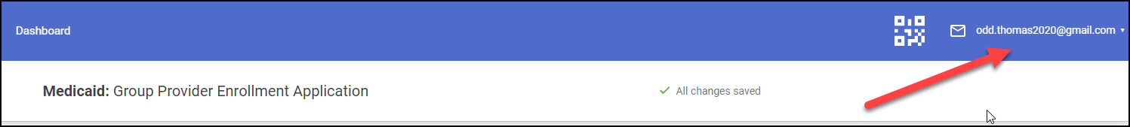 | - Navigate to your credentials (email address).
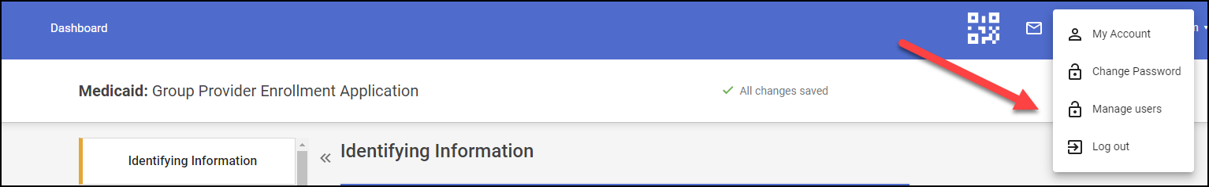 | - Navigate to Manage Users (found in the drop down below user’s email address)
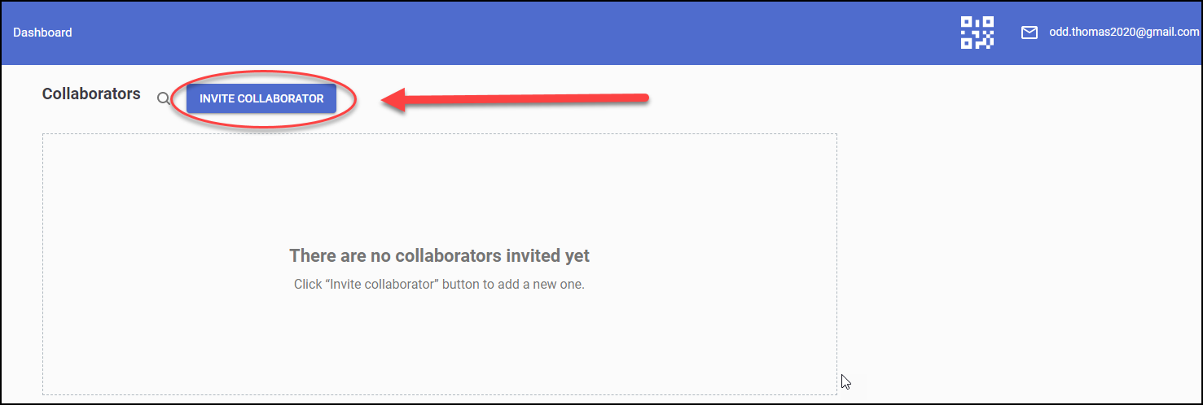 | - Click on Invite Collaborator
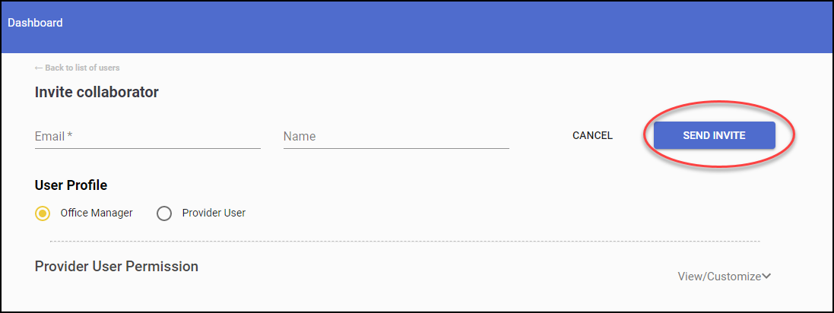 | - On the Invite collaborator page, specify the following data:  - Email  - Name  - Then select the User Profile. The collaborator types (with pre-defined privileges) are:  - Office manager  - Provider User
 | - You can change permissions if needed by clicking View/Customize.
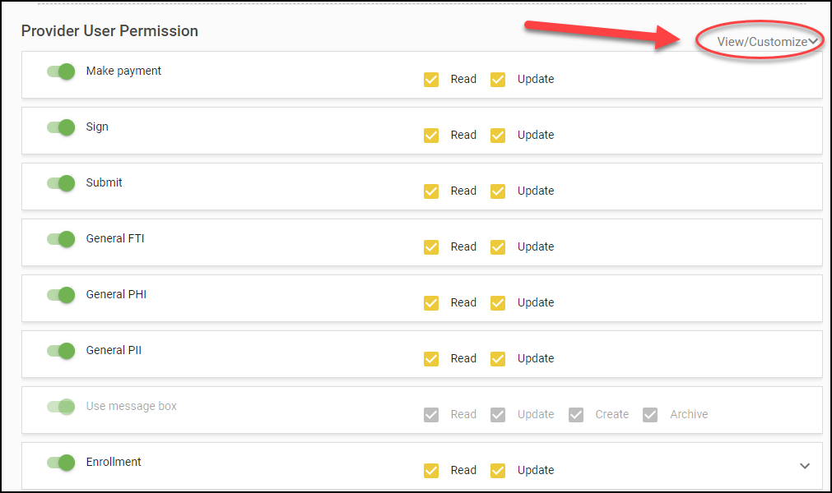 | - Check the appropriate permissions and then close View/Customize.  - Upon completion, click Send Invite.
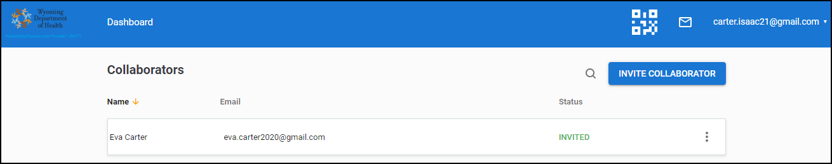 | - Once you have sent the invite you will see a grid with the collaborator you entered with a status of “Invited.” From there you can add another if you so choose.

