Provider Enrollment, Screening & Monitoring (PRESM)
Discover Your Provider (DyP): User Guide for an Individual Enrollment

Version: 1.1
Prepared for Wyoming Dept. of Health
Submitted:


Table of Contents
Contents
1 Introduction 6
2 Getting Started 6
3 Landing Page 6
4 User Registration 7
5 User Registration Page 8
6 User Login 10
7 Login Page 10
8 Dashboard 10
9 Enrollment Types 11
10 Security Sign 11
11 Starting the Enrollment Process for an Individual Enrollment Application 13
11.1 Identifying Information Section 13
11.2 Program Participation Section 15
11.3 Provider Identifier Number Section 15
11.4 Address Details 17
11.5 Taxonomy/License/Affiliation Information 19
11.6 Primary Service Location Section 20
11.7 Secondary Service Location Section 21
11.8 Request Retroactive Adjustment Section 22
11.9 Ownership Section 22
11.10 Key Personnel 24
11.11 Exclusion/Sanction Section 25
11.12 Upload Documents Section 25
11.13 Authorized Signature Section 26
11.14 Affiliation Section 27
11.15 Provider Agreement Section 27
11.16 Payment 30
11.17 Summary Section 31

Table of Figures
Figure 1: Provider Enrollment Welcome Page 6
Figure 2: Register to Provider Portal 7
Figure 3: Register to Provider Portal continued 7
Figure 4: Navigate to Login Screen 8
Figure 5: Registration Successful Message 8
Figure 6: Successful Registration Email Notification 9
Figure 7: Confirmation screen 9
Figure 8: Login Page 10
Figure 9: Welcome page 11
Figure 10: Security Sign 12
Figure 11: Security Pop-Up 12
Figure 12: approved provider dashboard 13
Figure 13: Identifying Information section, part 1 14
Figure 14: Identifying Information section, part 2 14
Figure 15: Program Participation section 15
Figure 16: Provider Identifier Number section, part 1 16
Figure 17: Provider Identifier Number section, part 2 17
Figure 18: Address Details section, part 1 18
Figure 19: Address Details section, part 2 18
Figure 20: Taxonomy/License/Affiliation Information section, part 1 19
Figure 21: Taxonomy/License/Affiliation Information section, part 2 19
Figure 22: Primary Service Location section, part 1 20
Figure 23: Primary Service Location section, part 2 20
Figure 24: Secondary Service Location section 21
Figure 25: Secondary Service Location button to create additional locations 21
Figure 26: Request Retroactive Adjustment section 22
Figure 27: Ownership section, part 1 23
Figure 28: Ownership section part 2 23
Figure 29: Key Personnel section, part 1 24
Figure 30: Key Personnel section, part 2 24
Figure 31: Exclusion/Sanction section 25
Figure 32: Upload Documents section 26
Figure 33: Upload Documents section, verified check mark 26
Figure 34: Authorized Signature section 26
Figure 35: Authorized Signature section 27
Figure 36: Affiliation section 27
Figure 37: Provider Agreement: 28
Figure 38: Provider Agreement: Signature Loading page 28
Figure 39: Provider Agreement: Getting Started 29
Figure 40: Provider Agreement: Signature page 29
Figure 41: Provider Agreement: Signature page continued 29
Figure 42: Provider Agreement: Final page 30
Figure 43: Payment Information details 30
Figure 44: Summary section 31
Figure 45: Dashboard page that opens after the application submission 31
Figure 46: Loading Signature Page 32
Figure 47: Signature Page, Get Started 32
Figure 48: Signature Page, after signing 33
Figure 49: Signature Page, almost done 33
Figure 50: Submitted successfully pop-up 33
Figure 51: Dashboard page that appears after submitting application 34

Revision History
Date | Version # | Assigned By | Version
01/27/2020 | 1.0 | Trainer | Creation/Initial draft
07/20/2020 | 1.0 | Trainer | Updated Initial draft
08/27/2020 | 1.0 | Trainer | Submission
10/19/2020 | 1.1 | Trainer | Resubmission
01/20/2021q | 1.2 | Trainer | Update

Introduction
Discover your Provider (DyP) is a solution built to provide wide-ranging functionality through the Provider Portal to include Provider Enrollment, Provider Self Service, and support for additional functionality. The purpose of the current guide is to provide useful enrollment information to individual providers. Also, this guide is intended to make the enrollment processes easier to navigate and understand. Individual providers must enroll using the Provider Enrollment portal to have the ability to submit claims and receive payment for covered services. After an enrollment application is submitted, a confirmation email is sent to the specified email address.

Getting Started
Before you begin the enrollment process, gather all the information you will need to enter during each step. Please review the following checklist:
- Social Security Number
- National Provider Identifier

Landing Page
The Discover your Provider landing page is not only a ground for the provider registration and/or login, but also an instrument for patients to search for an acting provider in their area. The landing page also provides information on the system features as well as specific information for providers.
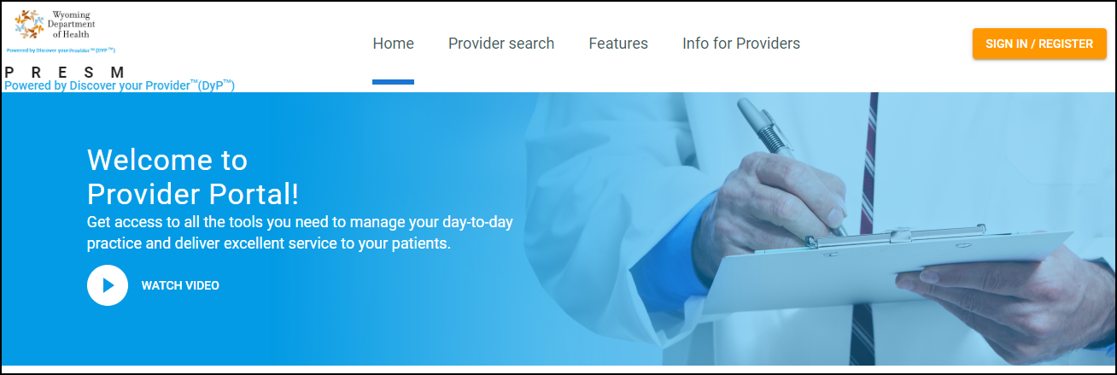
Figure 1: Provider Enrollment Welcome Page

User Registration
For a new user to register in the system, take the following steps:
- On the landing page, click Sign In/Register.
- On the Login pop-up window, click Register.
- On the Register to Provider Portal pop-up window that opens, specify the following data and click Register:
  - Email – email address, required
  - Password – password that must match the following criteria: 8 or more characters; upper- and lower-case letters; number and symbol; required
  - Validate Password – confirm the password
  - Organization Name – the official name of organization, optional
  - Organization Description – short description of an organization, optional
  - Prefix – name prefix, optional
  - First Name – first name, required
  - Middle Name – middle name, optional
  - Last Name – last name, required
  - Suffix – name suffix, optional
  - Phone – phone number, required
  - Extension – name extension, optional
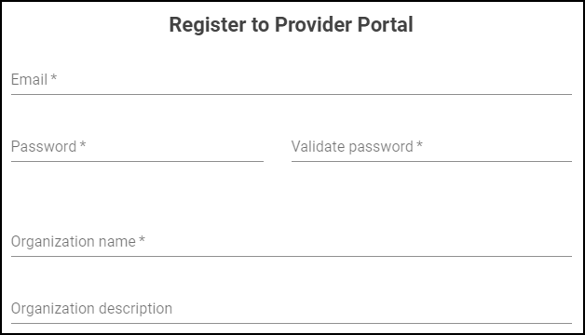
Figure 2: Register to Provider Portal
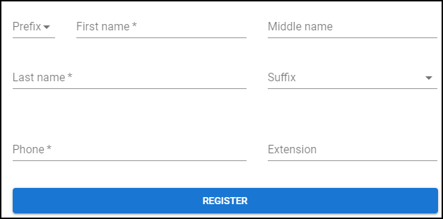
Figure 3: Register to Provider Portal continued

User Registration Page
If you moved to the registration page by mistake and you already have an account, click the Already have an account? Log in link (found below) to move to the Login page.

Figure 4: Navigate to Login Screen
Once you have entered the correct data and clicked Register, the Registration successful message is displayed. Follow the link from your designated email to confirm registration.
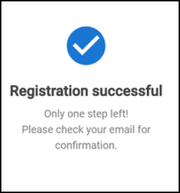
Figure 5: Registration Successful Message
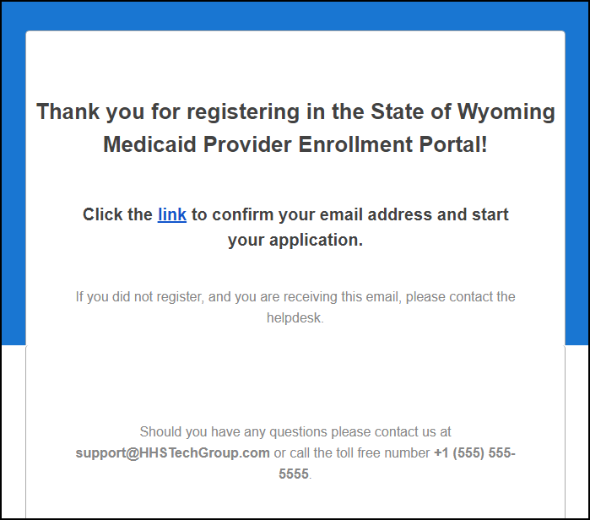
Figure 6: Successful Registration Email Notification
Once you click on the link you will be sent to this screen shown below. Click on the Back to Log In button and it will bring you back to the sign in page.
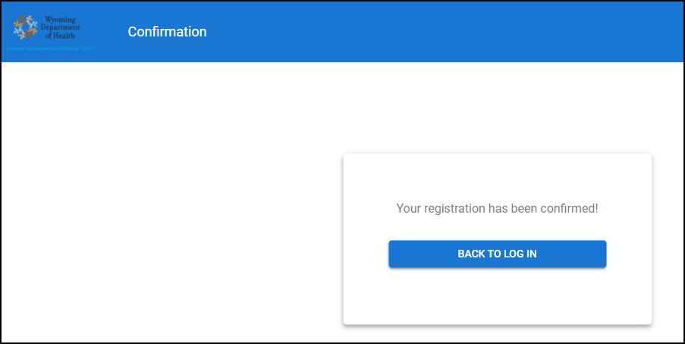
Figure 7: Confirmation screen

User Login
To log in to the system, on the landing page, click Sign In/Register. The Log into Provider Portal pop-up window opens. Specify the following data and click Log In:
- Username – email address specified during the registration
- Password – password specified during the registration
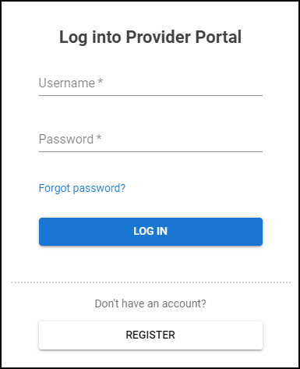
Figure 8: Login Page

Login Page
If you do not remember your password, click the Forgot password? Link and follow the steps to restore your password.
If you are not registered in the system, click Register.
Password Reset
To reset your password in case you forgot it, take the following steps:
- Click Forgot Password? On the user login page.
- On the Restore password page that opens, enter your email address and click Reset Password. Otherwise, click Back to Log In.
- Check your email and follow the link provided in it to restore the password.
- On the Change password page, enter your new password, confirm it, and click Change Password. The password change email confirmation is sent to you email address.

Dashboard
After logging in to the Provider Enrollment Portal for the first time, the Welcome page is displayed.
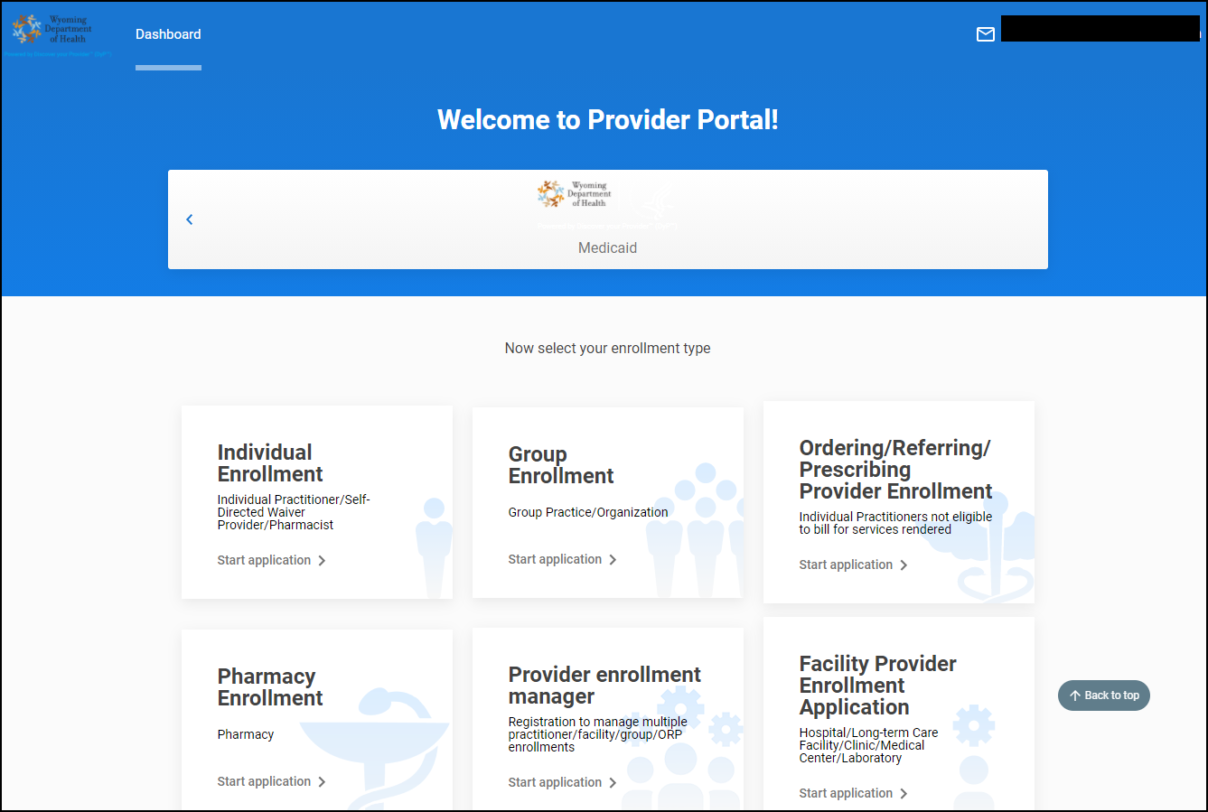
Figure 9: Welcome page

Enrollment Types
The Provider Management system provides the following types of enrollment depending on the type of provider:
- Individual enrollment
- Group enrollment
- Facility enrollment
- Pharmacy enrollment
- Ordering/referring/prescribing provider enrollment
- Provider Enrollment Manager enrollment

Security Sign
If you are logging in as an already enrolled provider, the Dashboard page has a different view with all functionality enabled. First however, you will see the following security sign:
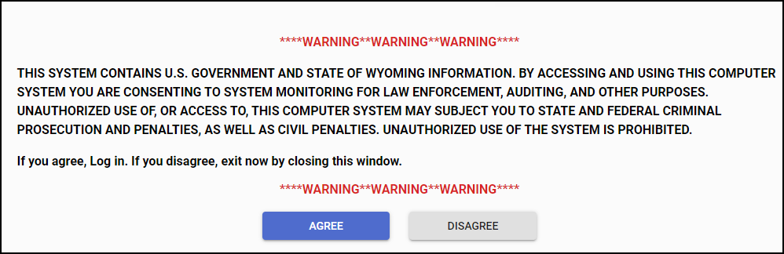
Figure 10: Security Sign
You must click ‘Agree’ before you are able to proceed. This will occur every time you log into DyP.
Once you click ‘Agree you will receive the following pop-up:
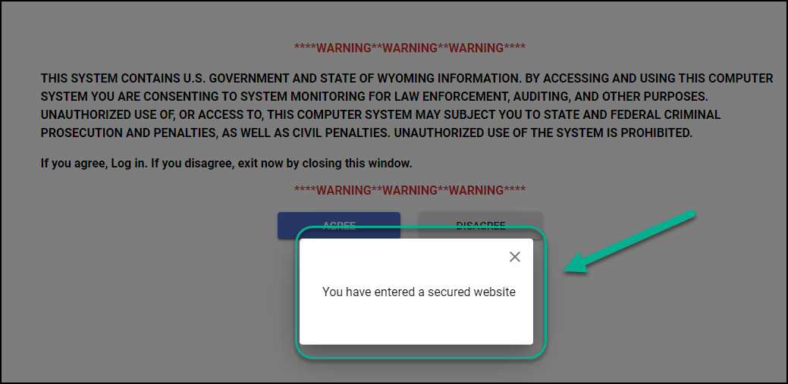
Figure 11: Security Pop-Up
Now that you have agreed and entered the secured website you are able to see the following on the DyP dashboard.
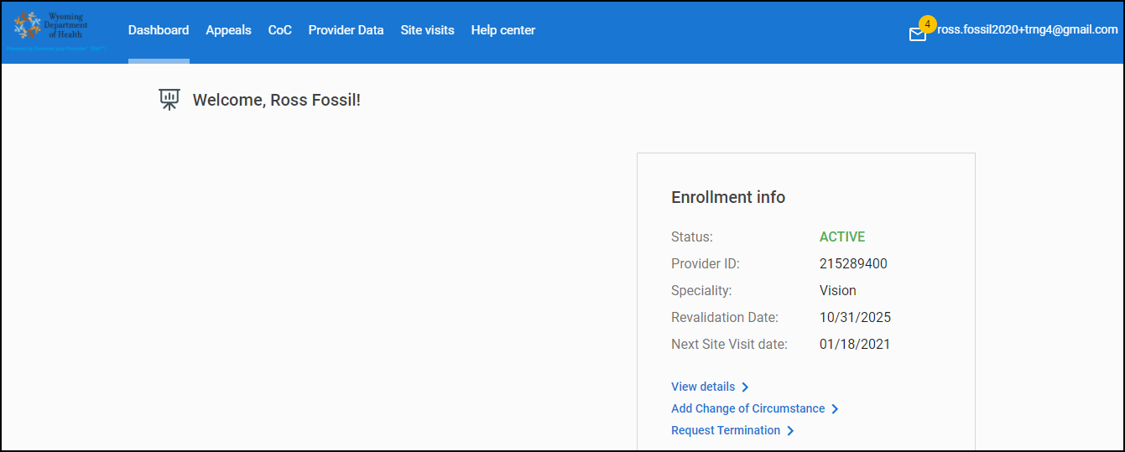
Figure 12: approved provider dashboard

Starting the Enrollment Process for an Individual Enrollment Application
To start filling in the individual enrollment application, follow the steps:
- On the Dashboard page, select the payer and the Individual Enrollment type.
- On the Individual enrollment application page that opens, fill in all the required sections, and click Submit on the final Summary page.

Identifying Information Section
The Identifying information section is used to describe the provider general information such as first and last name, gender, date of birth, as well as SSN and other tax-related data.
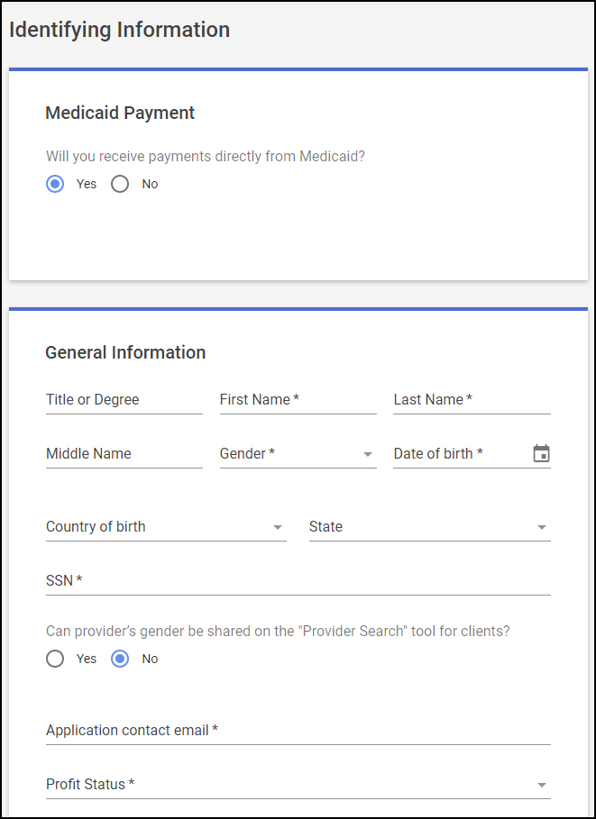
Figure 13: Identifying Information section, part 1

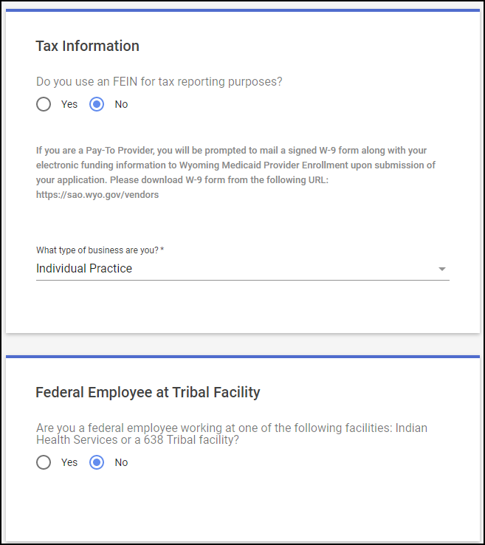
Figure 14: Identifying Information section, part 2

Program Participation Section
The Program Participation section is prefilled with Medicaid fee-for-service. The provider can click next knowing that this is the program they want to participate in.
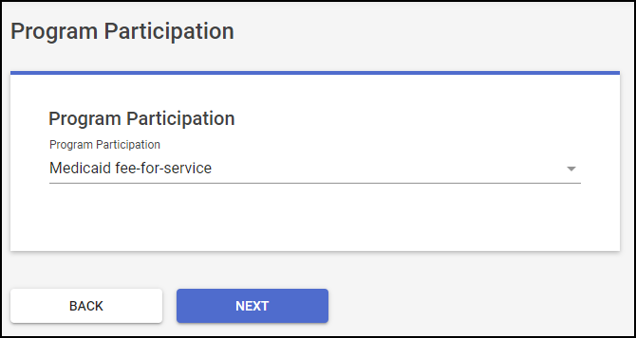
Figure 15: Program Participation section

Provider Identifier Number Section
The current section is used to indicate the provider NPI, as well as indicate if a provider is already enrolled in another state and/or wants to participate in Medicare P4P program.
The National provider identification field has a verification mechanism for NPI numbers. While entering, the system provides the list of available NPIs that match the entered value. If the NPI number is not valid, it will be impossible to proceed with enrollment.
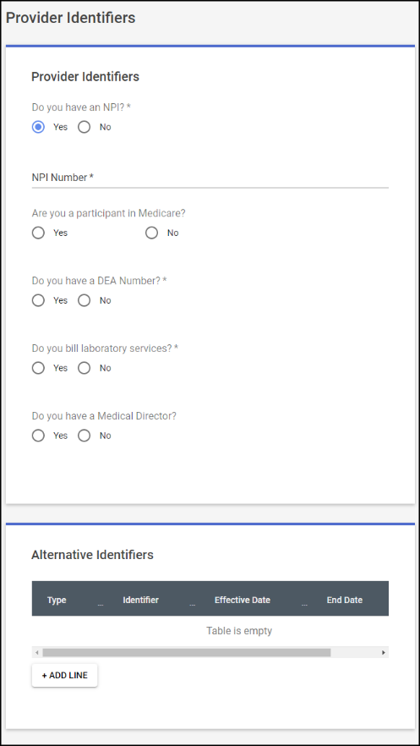
Figure 16: Provider Identifier Number section, part 1
Following the Alternative identifiers there are additional questions found in the Provider Identifiers section under the section title Additional Information.
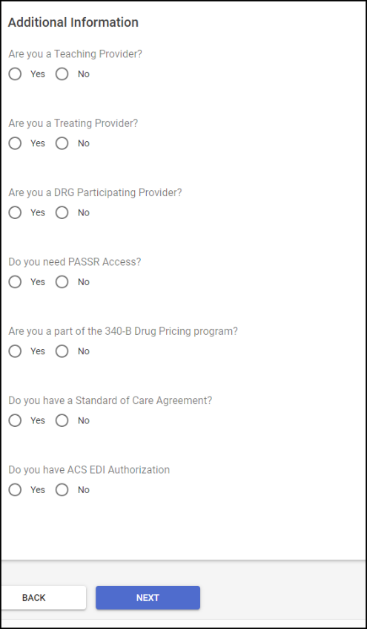
Figure 17: Provider Identifier Number section, part 2

Address Details
The current section includes information for provider mailing, billing, and service location addresses.
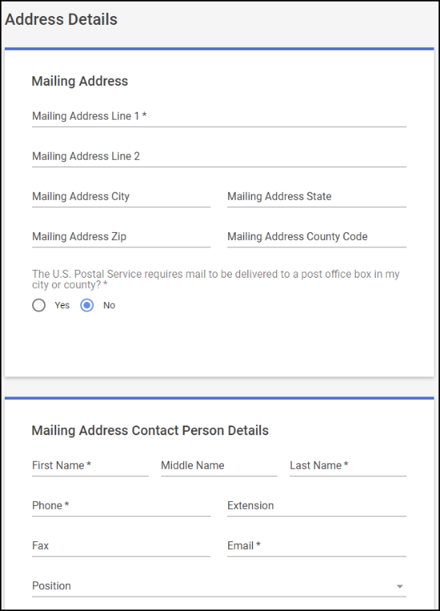
Figure 18: Address Details section, part 1
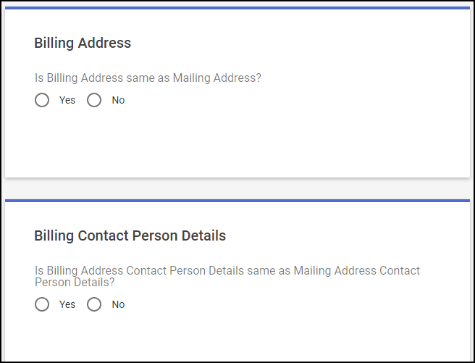
Figure 19: Address Details section, part 2

Taxonomy/License/Affiliation Information
This section you will select your taxonomy and additional taxonomy if applicable. Then you will add your license information in the table if prompted to do so based on your taxonomy. Then you can add your affiliation.
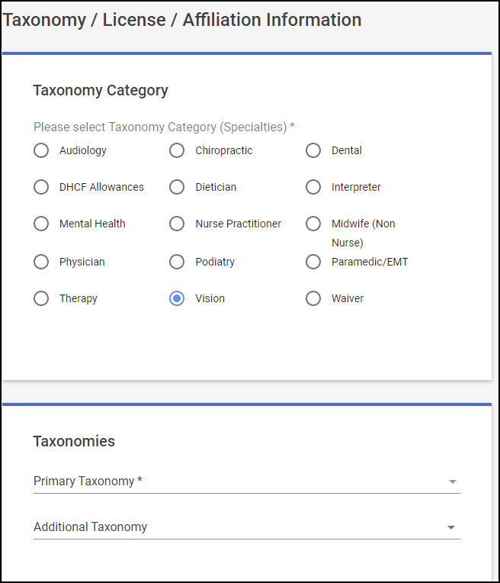
Figure 20: Taxonomy/License/Affiliation Information section, part 1
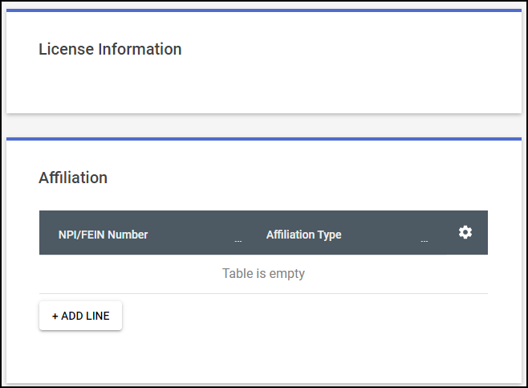
Figure 21: Taxonomy/License/Affiliation Information section, part 2

Primary Service Location Section
In the current section you will add your primary location address information and the contact person’s information for that primary location. You can also specify the gender of patients to be served, their age range, spoken languages, specify if the service is available in all counties or not, and open office hours.
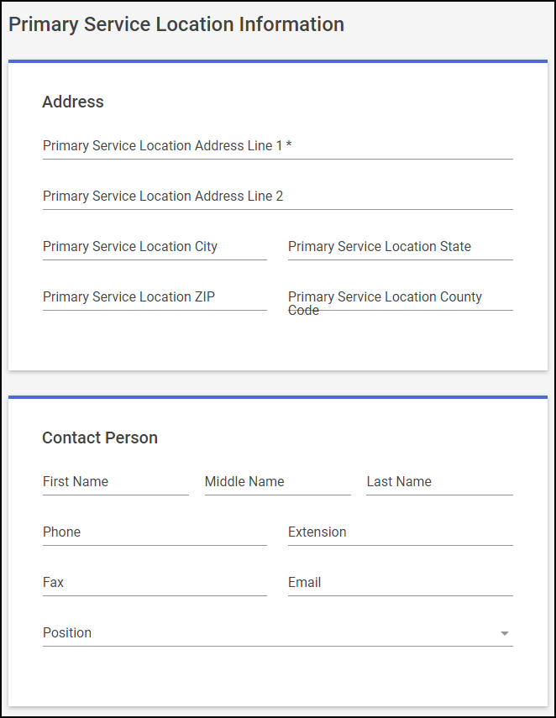
Figure 22: Primary Service Location section, part 1
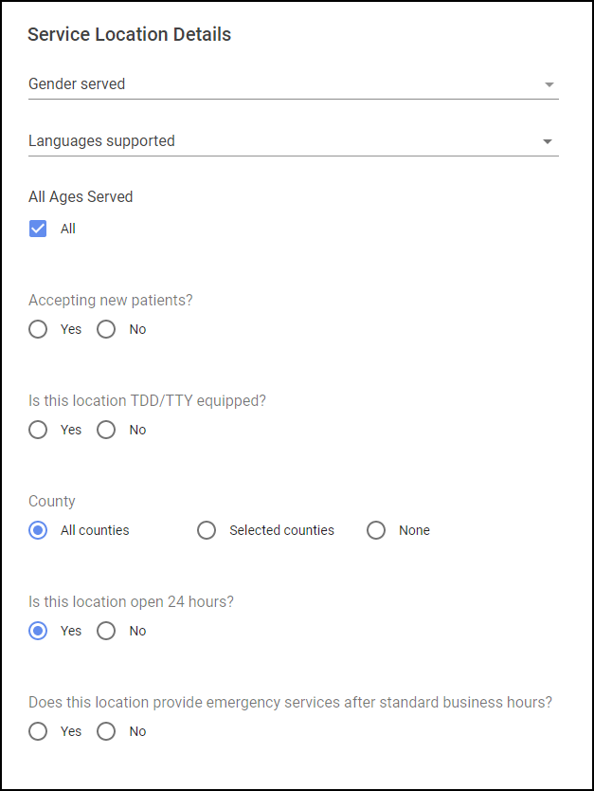
Figure 23: Primary Service Location section, part 2

Secondary Service Location Section
In the current section you will add your secondary location address information and the contact person’s information for that location. You can also specify the gender of patients to be served, their age range, spoken languages, specify if the service is available in all counties or not, and open office hours. You can add a maximum of 9 additional locations this way.
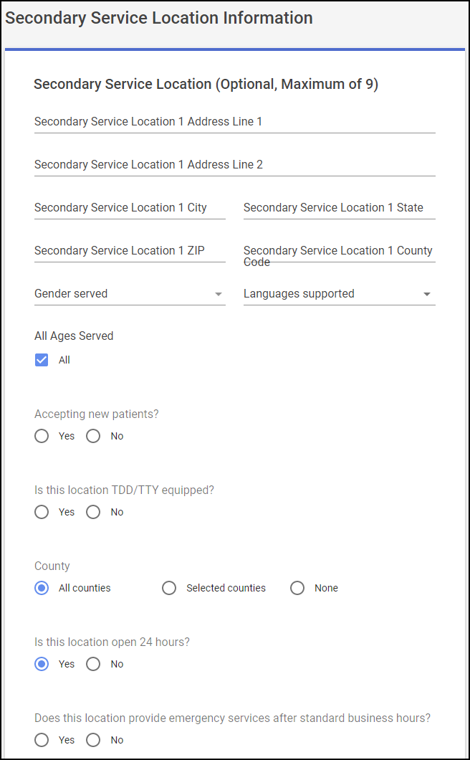
Figure 24: Secondary Service Location section
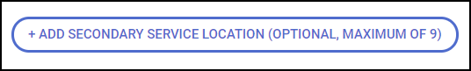
Figure 25: Secondary Service Location button to create additional locations

Request Retroactive Adjustment Section
This section gives you the option to state if you would like your enrollment to be retroactive. By selecting yes, two lines will populate allowing you to fill in the reason and the date for which you’d like your enrollment to begin on. The second question is regarding if you are an out-of-state provider and whether you are enrolled with another Medicaid or CHIP program.
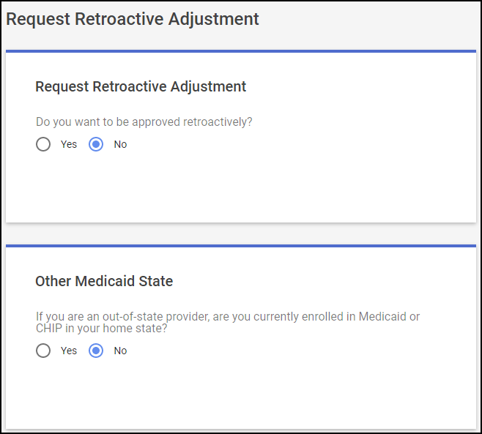
Figure 26: Request Retroactive Adjustment section

Ownership Section
The current section is used to indicate whether provider has ownership of an organization billing Medicare and/or if any of the provider family are related to the provider practice.
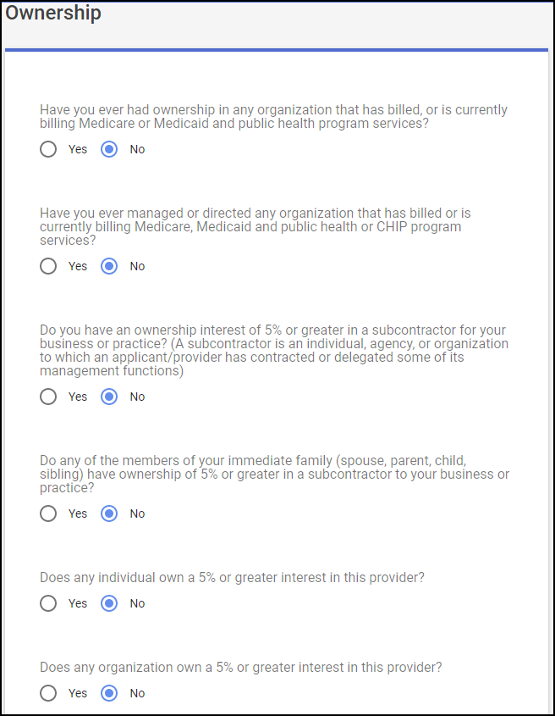
Figure 27: Ownership section, part 1
If you select “Yes” to any of the questions a table will populate specific to the question so that you may enter in the pertinent information. See below screenshot for an example.
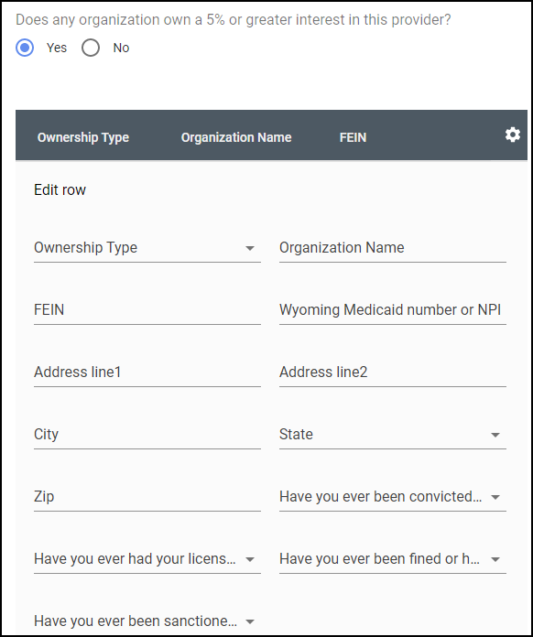
Figure 28: Ownership section part 2

Key Personnel
This section is for if you have a Managing Employee such as a Director, Supervisor, Manager, Officer, and/or Agent that you want documented on the enrollment. When you click on the + ADD LINE button it opens a table for you to fill out with all their important information.
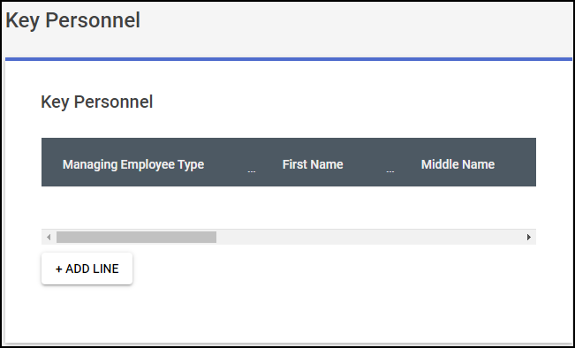
Figure 29: Key Personnel section, part 1
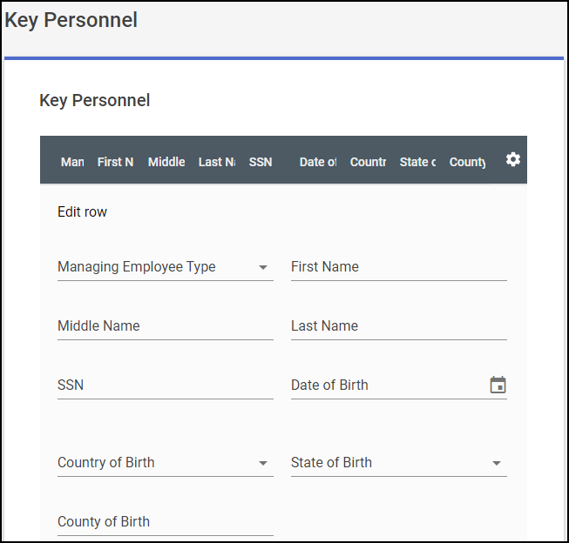
Figure 30: Key Personnel section, part 2

Exclusion/Sanction Section
The current section is used to indicate whether a provider or provider family member were convicted of a felony or excluded from a federal program and if there were any criminal fines, administrative sanctions, program exclusions, suspension of payment, etc. Note that these are mandatory questions. You will need to answer either yes or no to each question in order to successfully submit the application.
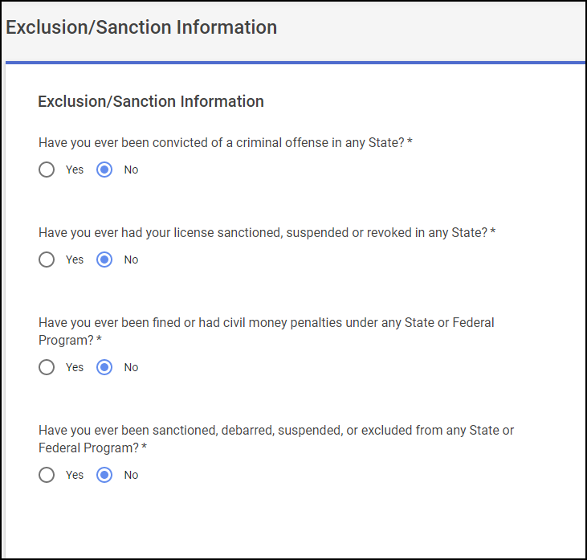
Figure 31: Exclusion/Sanction section

Upload Documents Section
The current section is used to upload different files and documents so that to accompany the enrollment application. These files include bank account number, current effective and non-expired license, board certification, trading partner agreement, NPI designation letter, etc. These documents must be attached to the corresponding sections.
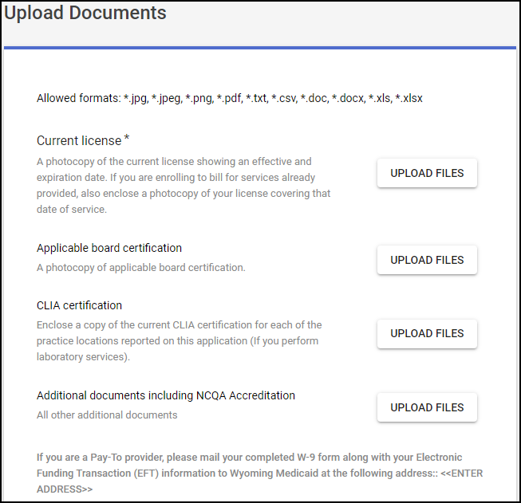
Figure 32: Upload Documents section
Once you have uploaded a document you will see the title with a white checkmark in a green circle under the section where you uploaded the document. See screenshot below.
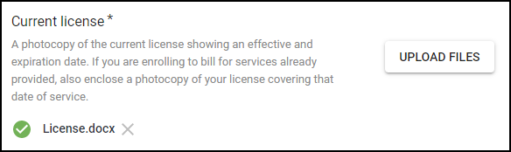
Figure 33: Upload Documents section, verified check mark

Authorized Signature Section
The current section provides information on a person who is submitting the enrollment including the electronic signature, printed title of a person submitting enrollment, and submission date. Note that the Title of the authorizing signer is a mandatory field.

Figure 34: Authorized Signature section
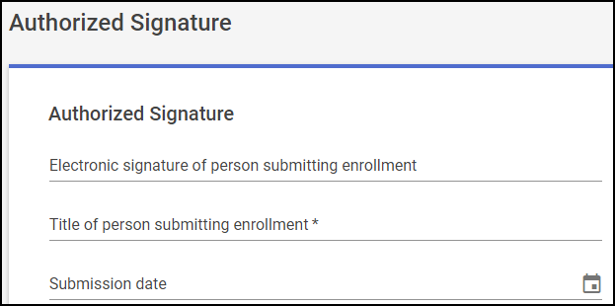
Figure 35: Authorized Signature section

Affiliation Section
This section is if a provider wants to affiliate to another group. This tab is not utilized for an individual enrollment. To navigate on click on ‘Next’ or you may click on the Provider Agreement tab found below the Affiliation tab and continue.
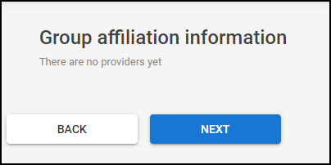
Figure 36: Affiliation section

Provider Agreement Section
This section is where the user will read through, understand the agreement, and then sign the document. To electronically sign the agreement, click on the ‘Agree and Sign’ button found at the bottom of the tab. Upon submitting your signature, you will return to the tab. From there you will see your name at the bottom of the document. Then click the ‘Next’ button. The next several screen shots depict the signing process.
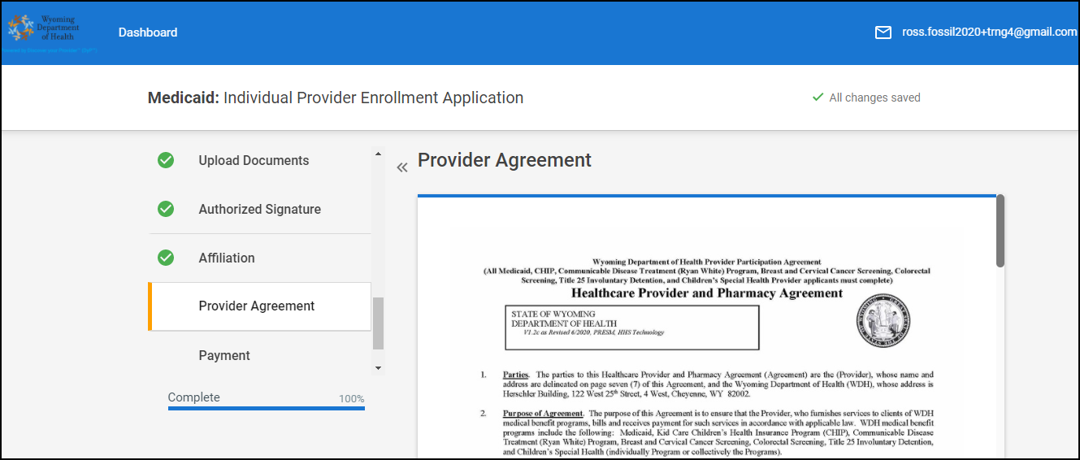
Figure 37: Provider Agreement:

Figure 38: Provider Agreement: Signature Loading page
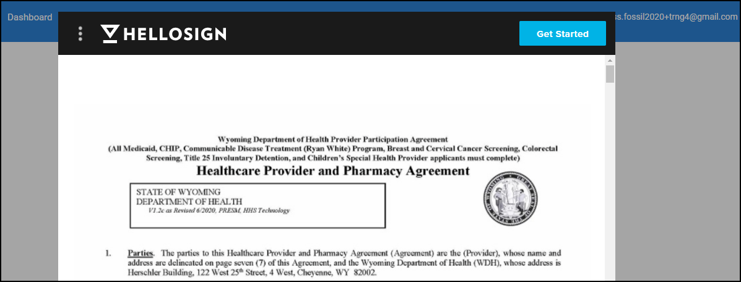
Figure 39: Provider Agreement: Getting Started
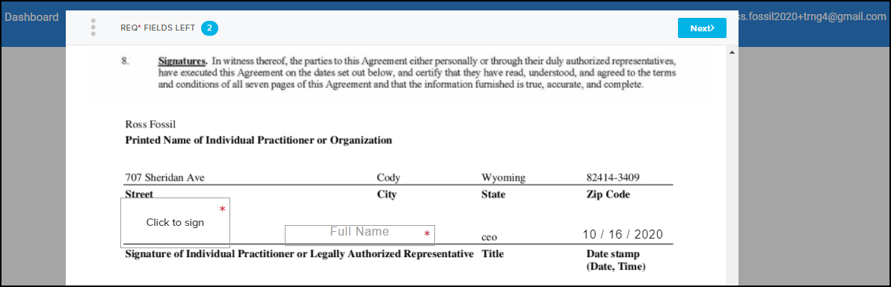
Figure 40: Provider Agreement: Signature page
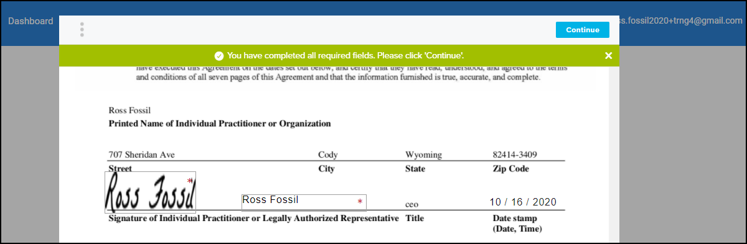
Figure 41: Provider Agreement: Signature page continued
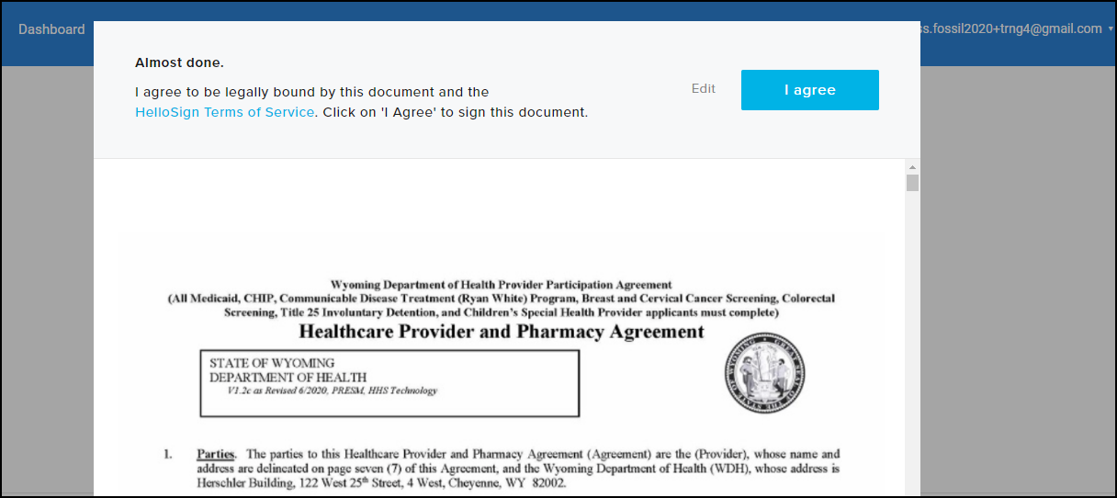
Figure 42: Provider Agreement: Final page

Payment
If you must pay a payment this screen will be active. Click on ‘DOWNLOAD INVOICE’ to complete your payment to enroll in the program.
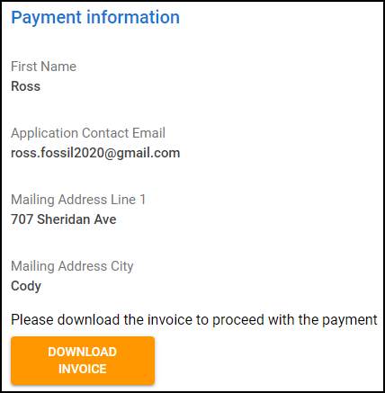
Figure 43: Payment Information details
Once you have downloaded the invoice open it up and follow the instructions inside. When sending a check make the check payable to ‘Wyoming Medicaid’ or ‘Division of Healthcare Financing’. Send your payment by check to 2515 Warren Ave, Suite 503, Cheyenne, WY 82001.
After you have successfully downloaded the invoice the user will be sent back to their application and they will be brought back to the Payment tab. From there click on ‘Next’.

Summary Section
On the Summary section, provider certifies that the entered information is true, accurate, and complete by selecting the corresponding Sign and agree to Terms and Conditions option. Clicking Proceed to Sign navigates provider to the Dashboard page from where they can sign an application.
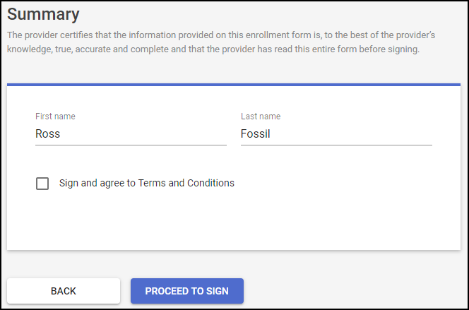
Figure 44: Summary section

On the Dashboard page that opens, the enrollment application is in the Ready for sign status. Click Sign to move to the application signature page.
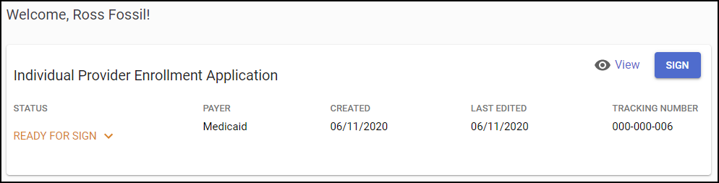
Figure 45: Dashboard page that opens after the application submission
The screen below appears while the signature site is loading.

Figure 46: Loading Signature Page
Then this screen appears. It will have all your information. Click on “Get Started”.
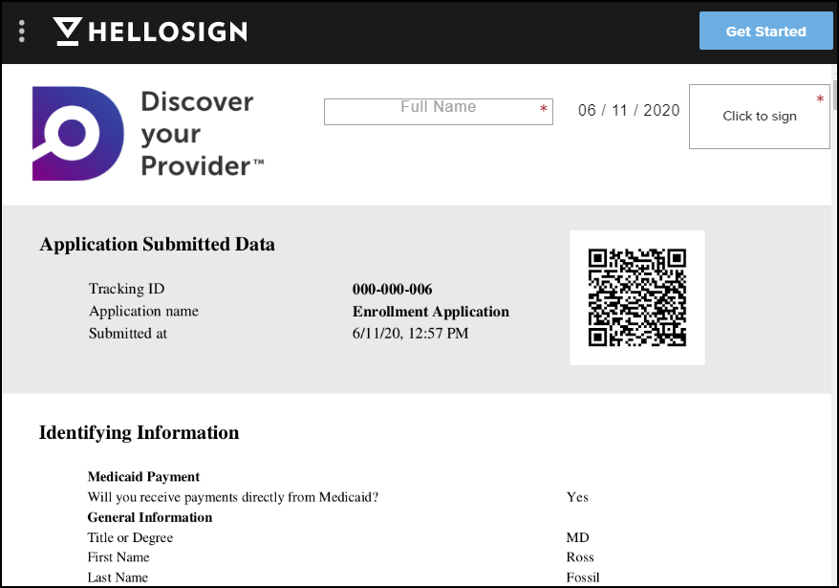
Figure 47: Signature Page, Get Started
Once you have electronically signed the document twice you will get the green banner asking you to “Please click ‘Continue’.
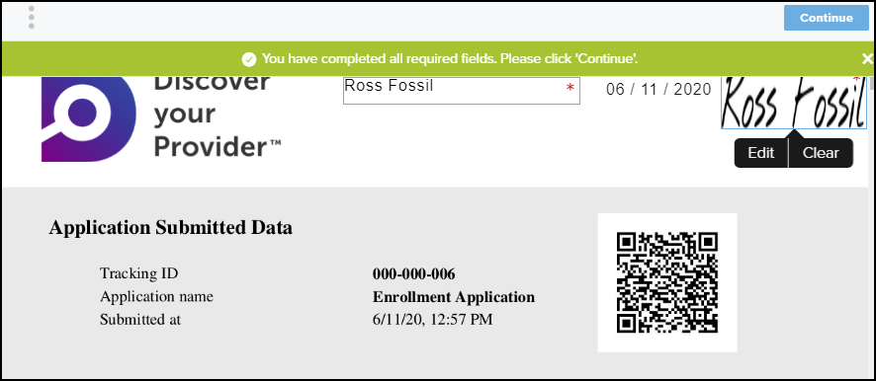
Figure 48: Signature Page, after signing
After you click ‘Continue’ you must agree to the Terms of Service by clicking ‘I agree’.
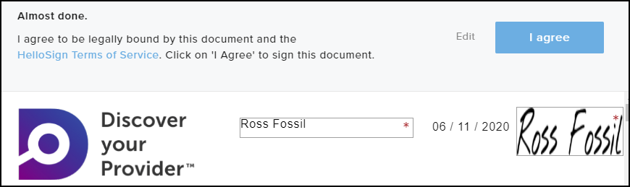
Figure 49: Signature Page, almost done
Then you will be brought back to the DyP portal where the following message will be displayed.
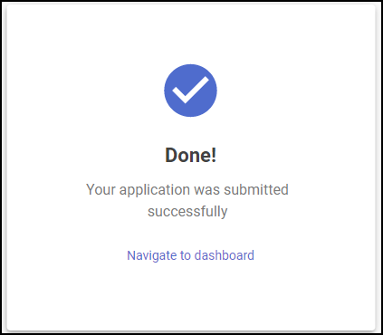
Figure 50: Submitted successfully pop-up

On the finish page, click Navigate to dashboard to view the status of your submitted application (can be already under review by an internal user).
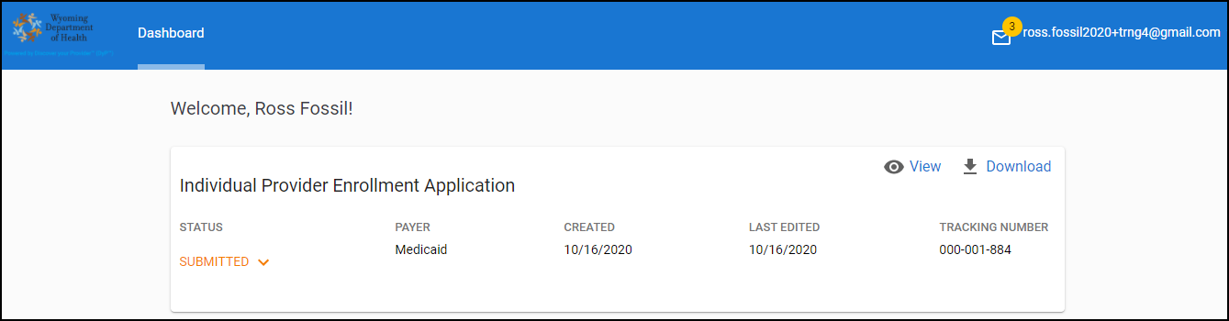
Figure 51: Dashboard page that appears after submitting application

From this page (shown above), you can view or download the application package by clicking the corresponding buttons.
The attachments zip application package archive includes the following documents:
- enrollmentApplication.pdf
- Payment_receipt <number>.pdf
- Plus, documents uploaded on the Upload documents tab during the application fill-in (if any)

